TDD_using_Junit5_and_Mockito_Hands_On_Task_1

Exercise 1: Setting Up Junit
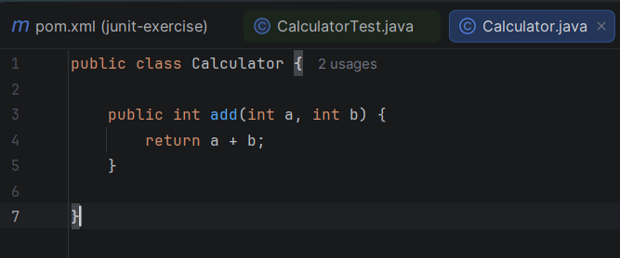
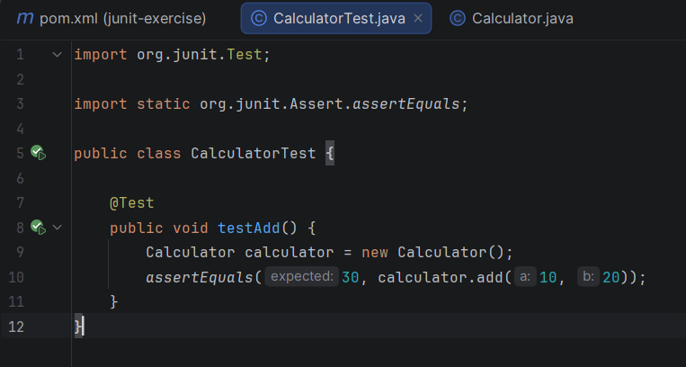
Output:
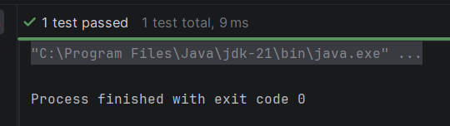

Exercise 3: Assertions in Junit
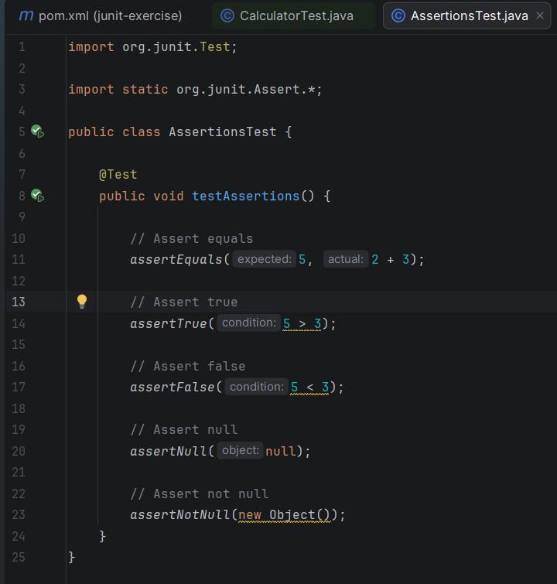

Output:
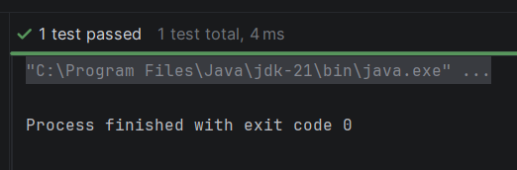

Exercise 4: Arrange-Act-Assert (AAA) Pattern, Test Fixtures, Setup and Teardown Methods in JUnit
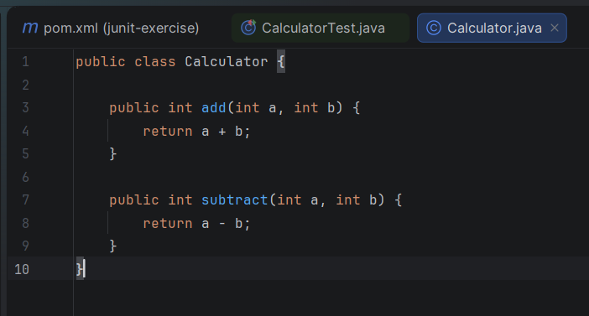

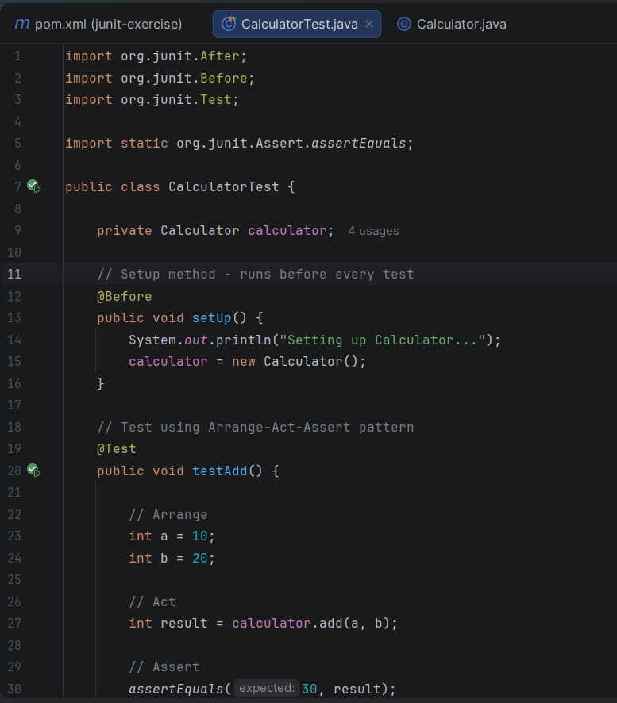
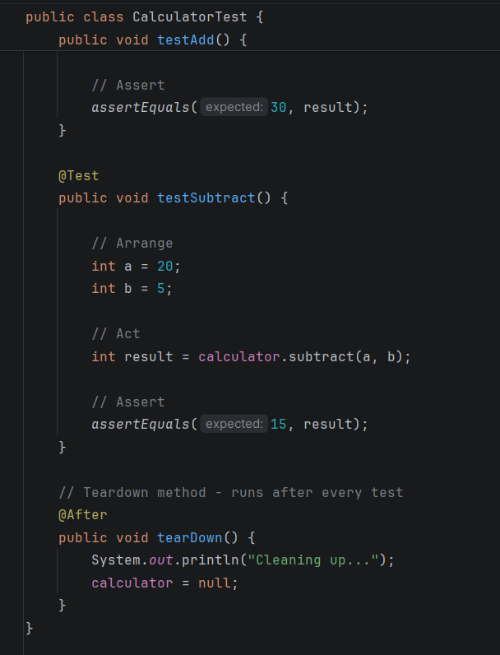

Output:
